JEVAJEVA

# Module 4

## 

## Data analytics Curricular Systems and Tools – Training Part I

### Module Learning Outcomes

Upon successful completion of this module, you will be able to

1. Identify the different content areas.
2. Identify the systems, tools, and resources needed for the program.
3. Identify the learning goals of online instruction.

### Module Overview Description

Welcome to the Data Analytics Curricular Systems and Tools module of Instructor Foundations. This module is going to introduce you to the Data Analytic program content, and resources. After this module you will be able to identify the curriculum framework, resources, tools, and systems you will need to be successful. Data Analytics Instructors play a critical role in the success of our students. You will be provided with all the support, tools, and resources that you need to be prepared for the classroom experience.

### Module Design

This module is broken into three lessons:

Lesson 1—Content Overview

Lesson 2—Content Tools, Resources, Systems

Lesson 3 — Assessment Requirements

The lessons are designed to be reviewed at a pace of your choosing.

### Module Content

#### Lesson 1—Content Overview

To ensure that you have a seamless transition into your role, you will be exposed to the unique aspects of the content and needed resources for the online classroom. This lesson will walk you through content structure to ensure your classroom runs smoothly and successfully. To make sure that you are properly prepared, there are pedagogical, technical, and administrative concepts that you will be introduced to. If you are new to the online classroom, there are significant differences between the traditional classroom environments. Instructing with technology, building your community, and keeping students engaged are just a few critical aspects in the expectation of your role. During this module you will learn:

* Pedagogical, technical, and administrative competencies necessary for effective online teaching.
* Key components of the online instructor onboarding process.
* Common methods for helping you achieve online teaching competencies.
* Effective strategies for teaching as a new Data Analytics online Instructor.
* Suggested ways you can adapt existing resources to the student’s need in the program.

The Data Analytics Program is made up of a total of 7 workshop sections, including 78 modules. A workshop section for example is Excel and within that section there will be a total of 10 modules. Each module is then made up of what are called lessons, that help break down the content to limit the feeling of being overwhelmed on the student side.

In a nutshell the content is broken down by:

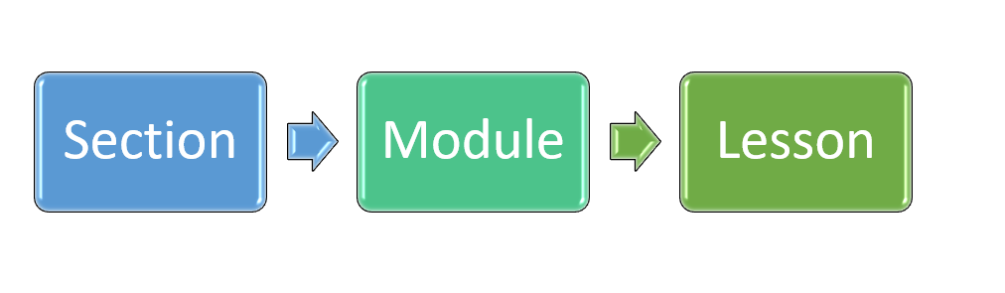

Let’s take a second to work through this and look at the image below. The very first section to be taught will be Excel. To the right there is a Module No. column. Those numbers are the list order of each Excel module. So, the first line is Excel Module 1. The module numbers will start over with each section.

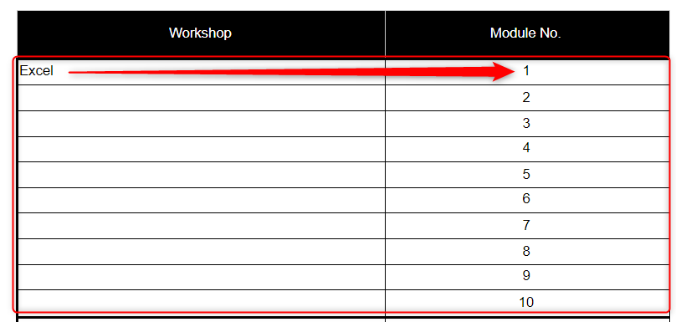

You will be provided with a workshop guided template for all content areas in upcoming modules. Those templates will give you all of the content, module learning outcomes, lesson video replays, and resources that students will work through and use. For now, here is a surface level overview on what sections you will be teaching and how many modules are included for each section. You can also view the [Data Analytics Syllabus for Instructors](https://docs.google.com/spreadsheets/d/19-_EhpzjEyzlnvsVMtlKK05K6b0CoIy-jd0Dz4YFLa0/edit?usp=sharing) for a more in depth look.

To summarize, here is a condensed depiction of each workshop section and the total number of modules that you will be instructing through the life of the Data Analytics program.

| **Workshop Section** | **Total Modules** |
| --- | --- |
| Excel | 10 |
| Presentations | 5 |
| SQL | 11 |
| Python | 12 |
| Tableau | 15 |
| Career Success (instructed by Career Success) | 1 |
| Tableau Desktop Specialist Certification Prep | 3 |
| AWS | 11 |
| AWS Certified Data Analytics Specialists Cert Prep | 4 |
| Portfolio Project | 5 |
| You’ve Made It, Student Graduation Ceremony! | 1 |

Aside from the content, at the end of each module students will be presented with a challenge activity to be completed in class to check their level of understanding. Those activities are made up of hands-on learning, multiple choice, scenario based, and walk through examples. This is a great opportunity for students to work through what they have just learned and ask questions when needed. This is where your expertise and professional experience will come into play. You will want to be confident in your skills and knowledge to walk students through questions, and areas they are finding to be challenging.

The Data Analytics program was created with student success in mind. We all know it can be challenging to keep our students engaged and need to change things up a bit. Throughout the program, students have been given 13 interactives that will give them a change of scenery outside of the classroom. The purpose of these interactives is so students can learn and review being hands-on. Depending on the content, some interactives have been placed as additional learning resources while others are placed as a challenge activity. Below is a list of 13 interactives. It is highly recommended you walk through these interactives. One, so you can see what the students will see. Two, so you can challenge yourself and see how well you perform on some of these.

* [Excel Charts](https://content.bridgepointeducation.com/curriculum/file/e5cbada3-1246-4e4d-9806-b3a630150371/1/FS_DA_charts_interactive.zip/story.html)
* [Excel Report and Interpret Findings](https://360.articulate.com/review/content/695dc98b-333b-4e48-931f-8f053d6f5ef1/review)
* [SQL Order of Operations](https://360.articulate.com/review/content/6df4432b-514a-4693-a1ac-b0286f9e5ef8/review)
* [SQL Aggregate Functions Self-Check](https://content.bridgepointeducation.com/curriculum/file/02f1bd4a-904d-40db-9ee6-f73d6a44c944/1/SQL%20Aggregate%20Functions.zip/story.html)
* [SQL Summary](https://content.bridgepointeducation.com/curriculum/file/43dde9d3-9be1-4ada-8d53-a955bc6a6517/1/SQL%20Summary.zip/story.html)
* [Python Fundamentals](https://content.bridgepointeducation.com/curriculum/file/da053006-be45-488b-85a0-2e03a367c5a0/1/Python%20Fundamentals.zip/story.html)
* [Python: Pandas and NumPy](https://content.bridgepointeducation.com/curriculum/file/13b6cb01-845a-415a-bbaf-80c7f8ac1aa4/1/Python%20Pandas%20and%20Numpy.zip/story.html)
* [Python: Introduction to Visuals](https://content.bridgepointeducation.com/curriculum/file/c569f4aa-b24c-4ac5-b122-c0333aa9ffe7/1/Python%20Introduction%20to%20Visuals.zip/story.html)
* [Python: Formatting Charts and Visuals Using Matplotlib](https://content.bridgepointeducation.com/curriculum/file/33f02522-5bad-482e-8e9d-a07356358038/1/Python%20Formatting%20Charts%20and%20Visuals%20Using%20Matplotlib.zip/story.html)
* [Tableau Data Sources Blending](https://content.bridgepointeducation.com/curriculum/file/b546238e-cd14-4b67-9937-9f67efcbff7d/1/Tableau%20Data%20Sources%20%26%20Blending%20Interactive.zip/story.html)
* [Tableau Understanding Calculations](https://content.bridgepointeducation.com/curriculum/file/4818985c-a21a-463c-9dfc-99feb8f16a3d/1/Tableau%20Understanding%20Calculations.zip/story.html)
* [Introduction to AWS](https://content.bridgepointeducation.com/curriculum/file/8045deac-a71f-49dc-a839-1dbba2bd212b/1/Intro%20To%20AWS.zip/story.html)
* [AWS Data Analytics Specialty](https://content.bridgepointeducation.com/curriculum/file/20ce1fbc-3f67-414c-b7b3-fdd69ab25e61/1/AWS%20Certified%20Data%20Analytics%20Specialty%20Prep%20Interactive.zip/story.html)

Outside of module challenge activities and interactives, you can show your creativity using [QuizWhip](https://quizwhip.co.uk/). QuizWhip is a live, virtual gaming console that lets your students compete with their peers in the classroom, and even you. Once you create a user profile you can schedule regular quizzes for your students that let them earn points and win prizes. You will create your own quizzes and student interaction. This is not required, but a highly recommended tool to gauge your student’s level of understanding and have some fun in class.

#### Lesson 2—Content Tools, resources, and systems

Now that you have been provided an overview of the program content, let’s walk you through the tools, resources, and system requirements that you will need to be successful in the classroom. The program content has been created with the mindset that students will not have to pay for any additional expenses where they do not have to. It is important that you as the Instructor have all of the tools and resources needed for all content areas to walk through live demos and additional examples based on student demand and need. Before jumping into the course content resources, take some time to familiarize yourself with the [Canvas Getting Started page,](https://resources.instructure.com/courses/32/pages/canvas-student-tour-videos) to get a sense of what the student is going to have access to upon starting the program. Students will walk through how to navigate their Canvas console and will watch a [Canvas Overview Video Tutorial](https://community.canvaslms.com/t5/Video-Guide/Canvas-Overview-Students/ta-p/383771).

This lesson is going to take you into a section breakdown on what tools and resources will be required for the program for you as the Instructor. You will also be given some additional resources that will help strengthen your knowledge in the classroom. The list below outlines all of the required resources across sections and some additional resources. It is encouraged that you familiarize yourself with each. If you are working in or have other resources for each, please feel free to utilize those in class. We want students to have exposure to all of the tools they could potentially be working with once they graduate from the program.

Excel:

* Required Tools:
  + [Microsoft Excel](https://www.microsoft.com/en-us/microsoft-365/excel)
* Additional resources:
  + [GeeksforGeeks](https://www.geeksforgeeks.org/)

Presentations:

* Required tools and resources:
  + [Microsoft PowerPoint](https://www.microsoft.com/en-us/microsoft-365/powerpoint)
* Additional tools and resources:
  + [Slides Carnival](https://www.slidescarnival.com/)

SQL:

* Required tools and resources:
  + [myCompiler](https://www.mycompiler.io/view/4lYQ3pG)
* Additional tools and resources:
  + [W3schools SQL for Beginners](https://www.w3schools.com/sql/)
  + [SQL TUTORIAL](https://www.sqltutorial.org/seeit/)
  + [SoloLearn](https://www.sololearn.com/learning)

Python:

* Required tools and resources:
  + [Python](https://www.python.org/)
* Additional tools and resources:
  + [SoloLearn](https://www.sololearn.com/learning)
  + [W3schools Python for Beginners](https://www.w3schools.com/python/)

Tableau / Tableau Desktop Specialist Certification Prep:

* Required tools and resources:
  + [Tableau Public](https://public.tableau.com/en-us/s/). This website is where students can create a Tableau Public account and download the free app.
  + [Tableau Desktop](https://www.tableau.com/support/releases). This website is where students can create a Tableau Desktop account and download the app for a 14 free trial.
  + [A student’s guide to Tableau and the desktop specialist exam](https://www.tableau.com/about/blog/2020/5/students-guide-tableau-and-desktop-specialist-exam). This blog is an individual’s experience with learning Tableau and their journey to passing the Desktop Specialist certification exam.
* [Desktop specialist exam guide](https://mkt.tableau.com/files/DesktopSpecialist_ExamGuide.pdf). This is the sample exam guide that provides students with exam style questions and content areas to focus on to be successful in passing the exam.
* [Required exam setup](https://mkt.tableau.com/files/Tableau-Certification-4-steps-to-exam-success.pdf). This template walks students through how to properly prepare their testing environment and secure their connection prior to the exam.
* Additional tools and resources:
  + [Tableau Gallery](https://public.tableau.com/en-us/gallery/?tab=viz-of-the-day&type=viz-of-the-day)
  + [Kaggle](https://www.kaggle.com/datasets)
  + [US Government's open data](https://www.data.gov/)
  + [Cloud Native Data Catalog](https://data.world/)

Career Success:

* Career Success will be providing their own learning materials. You will be in communication with your Director, Career Success, and Career Success Coaches when you are about to start this portion of the program. There are no required tools for this section. However, if you are well-versed in [LinkedIn](https://www.linkedin.com/) and Resume Building, we encourage you to share your professional experiences with your students. Here is a resource that will help you and the students gauge their career path and working through the skills:
  + [Dice.com](https://www.dice.com/)

AWS / AWS Data Analytics Specialty Certification Prep:

* Required resources:
  + [AWS Free Tier](https://aws.amazon.com/free/?all-free-tier.sort-by=item.additionalFields.SortRank&all-free-tier.sort-order=asc&awsf.Free%20Tier%20Types=*all&awsf.Free%20Tier%20Categories=*all)
  + [AWS Certified Data Analytics Specialty](https://aws.amazon.com/certification/certified-data-analytics-specialty/)
* Additional resources:
  + [AWS Hands-On Tutorials](https://aws.amazon.com/getting-started/hands-on/?getting-started-all.sort-by=item.additionalFields.sortOrder&getting-started-all.sort-order=asc&awsf.getting-started-category=*all&awsf.getting-started-level=*all&awsf.getting-started-content-type=*all)

Project Portfolio:

* Required resources:
  + [Kaggle](https://www.kaggle.com/datasets)
  + [US Government's open data](https://www.data.gov/)
  + [Cloud Native Data Catalog](https://data.world/)
* Additional resources
  + [ObservePoint](https://resources.observepoint.com/blog/10-tips-for-presenting-data)
  + [SlideCarnival](https://www.slidescarnival.com/?amp)

While students are working through the program, they will be provided with a workshop guide for each section. As they progress through each lesson, they will use the guided workbooks to take notes and reflect on their learning. We encourage them to take notes on vocabulary, concepts, processes, and key ideas. They can modify the workbook templates to support their learning style. The workbooks are not a program requirement and will not be graded. However, it is a good idea for them to capture their learning so that they can make the most out of their educational investment. Here is the [Databases and SQL](https://docs.google.com/file/d/1ZKOXklGY5oZduAXOi21AGfjmvYwrzOow/edit?usp=docslist_api&filetype=msword) guided workbook for reference. Take some time to review this and it’s contents. You want to be aware of all the student resources they will be receiving. We will take a deep dive into content in the upcoming module.

#### Lesson 3— Assessment Requirements

Students will not be expected to do any outside of the classroom assignments, with the exception of assessments. However, if a student is falling behind in class, needs to catch-up, or wants to work ahead to be prepared, that is not required. During the course of the program, it is important to check for student understanding in what they are learning and how they can apply those key concepts and fundamentals. Below is a breakdown of the assessment expectation for students and the % of each.

| Assessment name | % of grade | Assessment description |
| --- | --- | --- |
| Excel | 10% | Take-home assessment |
| Presentations | 10% | Take-home assessment |
| SQL | 10% | Take-home assessment |
| Python | 10% | Take-home assessment |
| Tableau | 10% | Take-home assessment |
| Tableau Desktop Specialist | 10% | Take-home assessment |
| AWS Certified Data Analytics - Specialty | 10% | Take-home assessment |
| Portfolio Project | 30% | Final project |
|  | 100% |  |

Each assessment will have a customized rubric to measure student performance. The purpose of the scoring guides is to assess the student’s comprehension and application, across all modules. Grading style is meant to be objective, with yes or no responses. Please, review the [Excel Foundations and Presentations Assessment Rubric](https://drive.google.com/file/d/1rOy5Em660Al84kF72TmZcAaGhPloFzOI/view?usp=sharing) for the format and structure of what areas of grading will be covered. Each assessment will be formatted and catered to the content the student had learned in those sections.

As the Instructor, you will be responsible for grading the student’s assessments and final projects. At your discretion, you are allowed to curve scores, give extensions, and consider non-score factors (like someone attending office hours) when determining whether to give a certificate of completion.

For students to successfully pass each assessment, it is suggested they receive 70% or higher of a Basic or Proficient rating (with the exception of the portfolio project). Each Below selection will be worth zero. The scoring system for each rubric, will be based on a percentage correct scaling. If the student does not get all correct, the instructor should provide feedback and offer the student a second attempt to get all questions correct.

For the final portfolio project, it is suggested that a student get 100% to complete the bootcamp successfully. The goal is to ensure that students are ready and comfortable in joining the working world of data analytics.

# Module 5

## Do Something Great neon sign

## Data Analytics Curricular Training - Part II

### Module Learning Outcomes

Upon successful completion of this module, you will be able to

1. Identify the different content areas.
2. Define the workshop section overviews.
3. Define student learning outcomes across all workshop sections.

### Module Overview Description

Welcome to the Data analytics Curricular Training Part II module of Instructor Foundations. This module is going to introduce you to the content details of the program. Each lesson will go over the workshop section overviews and student learning outcomes. After this module you will be able to identify the order and sequence ideology of the program. Data Analytics Instructors play a critical role in the success of students. You will be provided with all the foundational knowledge that you need to be prepared for the classroom experience.

### Module Design

This module is broken into five lessons:

Lesson 1—Excel and Presentations

Lesson 2—SQL and Python

Lesson 3 - Tableau and Certification Prep

Lesson 4 - AWS and Certification Prep

Lesson 5 - Project Brief

The lessons are designed to be reviewed at a pace of your choosing.

At the end of this program, students will be able to:

1. Create compelling visuals of complex functions and formulas.

2. Evaluate findings using business objectives and key performance indicators (KPIs).

3. Apply SQL and Python programming to raw data to help stakeholders make business decisions.

4. Analyze data using cloud platforms and apply data patterns to guide your audience in making effective decisions.

5. Show how to give data a clear and easy to hear voice by creating data dashboards and models.

6. Create and showcase a final presentation that demonstrates your data analytics in the areas of research, wrangling data, and applying complex functions and programming to raw data.

7. Identify stakeholder audiences that will make informed decisions based on the business objective and analytical findings.

#### Reminder:

All workshops are made up of lessons and challenge activities that will extend student knowledge beyond basic fundamentals and core concepts. Workshops were designed to teach various tips and tricks to help students organize and tell their story of their analyzed data. Students will go through situational overviews using lesson videos to dramatically improve their data analytic applications and skills.

### Module Content

#### Lesson 1— Excel and Presentations

The Excel and Presentations sections of the program make up a total of 15 modules. These are the first two sections students will be introduced to. These sections may seem mundane to a skilled professional like yourself, but we need to remember we all started with Excel. After all, it is the veteran of Data Analytics! The layout of this program is through the lens of a student who has had no exposure to analytics. This lesson covers an overview of Excel and Presentation workshops, along with workshop learning outcomes.

**Excel**:

Data Analytics and Excel Foundations will help students gain the knowledge and skills they need to be a successful analyst. They will learn the fundamentals in capturing and recording important data. From creating and editing worksheets, using formulas and functions, sorting and filtering, they will be able to provide a detailed summary of raw data. The ability to effectively communicate and interpret findings will be done through strong data visuals and key performance indicators. This workshop will prepare them to help stakeholders make effective decisions based on analytical findings.

Upon successful completion of this workshop, students will be able to:

1. Breakdown data analysis terminology for comprehension, application using Excel.
2. Identify the role of a Data Analyst.
3. Identify and create complex functions.
4. Create and manipulate pivot tables and charts.
5. Identify trends based on pivot table and chart data.
6. Interpret and report findings using business objectives and identify key performance indicators (KPIs).

**Presentations**:

The Art of Presentations and Storytelling will help students gain the knowledge and skills they need to effectively communicate their findings as an analyst. They will learn the fundamentals in creating quality presentations. From learning PowerPoint and effective design, to identifying how to embed data and create strong visuals, they will provide a detailed summary of your analysis. The ability to effectively communicate and interpret findings will be pulled together to showcase their hard work. This workshop will prepare them to help stakeholders make effective decisions based on analytical findings.

Upon successful completion of this workshop, students will be able to:

1. Recognize the importance of quality presentations.
2. Identify the types of questions to ask when designing a presentation.
3. Demonstrate steps to design slides.
4. Recognize the difference between tables, graphs, and charts in PowerPoint.
5. Apply data design elements for charts, tables, and graphs.
6. Identify key concepts to include in a presentation.

#### Lesson 2— SQL and Python

After students learn the basics and fundamentals of Excel and presenting their findings, they will then jump into SQL and Python to follow. These two sections make up a total of 23 modules of the program. This lesson covers the overview for both SQL, Python, while providing you with the workshop learning outcomes.

**SQL**:

Databases and SQL will help students gain the knowledge and skills they need to effectively communicate findings using databases and programming. They will learn the fundamentals of SQL, how to create queries, and data tables. From fundamentals, basic operators, to building complex queries, letting them provide a summary of their data through SQL tables. The ability to work in databases to manipulate data is a strong skill to master as a data analyst. This workshop will prepare them to help stakeholders make effective decisions based on analytical findings, using SQL databases.

Upon successful completion of this workshop, students will be able to:

1. Identify how SQL is structured.
2. Combine SFWGHO to create basic queries.
3. Define SQL terminology and key words
4. Demonstrate how to identify and create queries using JOINs
5. Demonstrate SQL fundamentals by creating syntax using aggregate functions
6. Identify different date data types and how to work with each in a table.

**Python**:

Python will help students gain the knowledge and skills they need to effectively communicate your findings as an analyst. They will learn the fundamentals of creating quality syntax using Python’s programming language. From learning basic syntax, creating data series, manipulating data, importing libraries, the power of visuals, and machine learning, they will provide a detailed summary of their analysis. The ability to effectively communicate and interpret findings will be pulled together using a much desired programming language to showcase their hard work. This workshop will prepare students to help stakeholders make effective decisions based on analytical findings and impress them with their coding abilities.

Upon successful completion of this workshop, students will be able to:

1. Define Python programming language and key terminology.
2. Define and understand different data types and operating functions.
3. Demonstrate how to import and use Python libraries.
4. Demonstrate how to error check and clean data.
5. Demonstrate how to create and format visuals.
6. Apply machine learning concepts to run basic statistical analysis.

#### Lesson 3— Tableau and Certification Prep

Students will take a turn from programming and start to learn the fundamentals using one of the most common business intelligence tools, Tableau. Tableau makes up a total of 15 modules of the program. Of these modules, 12 are content learning, fundamentals, application building and 3 modules are designed around the Tableau Desktop Specialist Certification. Tableau is one of the leading BI tools in the Data Analytics industry. This program will not only add to the students ability to learn a BI tool but will also prepare them to be successful to obtain the Tableau Desktop Certification. The certification is not a program requirement but highly encouraged.

**Tableau**:

Tableau will help you gain the knowledge and skills you need to effectively communicate your findings as an analyst. You will learn the fundamentals of creating quality visuals using a business intelligence tool. From learning basic calculations, connecting to data sources, manipulating data, importing files, the power of visuals, and creating stories, you will provide a detailed summary of your analysis. The ability to effectively communicate, interact with, and interpret findings will be pulled together using a much desired business intelligence tool to showcase your hard work. This workshop will prepare you to help stakeholders make effective decisions based on analytical findings and impress them with your data visualization abilities.

Upon successful completion of this workshop, students will be able to:

1. Discuss the difference in data characteristics and data types.
2. Demonstrate how to use one measure for multiple actions, while creating filters and subcategories.
3. Define the different types of tables, while identifying how to drill into the data.
4. Identify how to create basic calculated fields, plot calculated fields, and interpret them.
5. Identify the difference between basic calculations and aggregate calculations.
6. Apply data visualization concepts, such as forecasting and spotting trends to create dashboards and data stories

**Tableau Desktop Specialist Certification Prep**:

Tableau Desktop Certification Prep will help you gain the knowledge and skills you need to effectively communicate your findings as an analyst and to successfully complete the certification exam. You will review the fundamentals of creating quality visuals using the business intelligence tool, Tableau. This workshop will walk you through sample exam questions that cover basic calculations, connecting to data sources, manipulating data, importing files, the power of visuals, and creating stories.The ability to effectively communicate, interact with, and interpret findings will be pulled together using a much desired business intelligence tool to showcase your hard work. This workshop will prepare you to take the next step to show your skills and talents to stakeholders, impress them with your data visualization abilities, and achieve certification.

Upon successful completion of this workshop, students will be able to:

1. Define what the Tableau Desktop Specialist Certification is.
2. Identify how the exam will assess your knowledge.
3. Demonstrate how to prepare for the exam.
4. Demonstrate how to apply worksheet analytics to your organized data, while answering sample exam questions.
5. Demonstrate how to pull it all together creating a dashboard and story.

#### Lesson 4— AWS and Certification Prep

Students will be wrapping up the program with Amazon Web Services (AWS). AWS is one of the leading cloud platforms in the Data Analytics industry. This program will not only add to the students ability to learn a serverless cloud based platform, but will also prepare them to be successful to obtain the AWS Data Analytics Specialty Certification.The certification is not a program requirement but highly encouraged. These sections make up a total of 15 modules of the program.

**AWS**:

Amazon Web Services(AWS) will help students gain the knowledge and skills they need to perform well in a serverless, cloud based platform. Students will learn the different types of analytic services offered by AWS. From learning basic storage solutions, connecting to data sources, manipulating data, importing/exporting files, and the power of visuals, they will be able to successfully operate across multiple platforms. provide a detailed summary of your analysis. The ability to effectively communicate, interact with, and interpret findings will be pulled together using a much desired online, cloud platform tool to showcase their hard work. This workshop will prepare them to help stakeholders make effective decisions based on analytical findings and impress them with their cloud platform abilities.

Upon successful completion of this workshop, students will be able to:

1. Define what Amazon Web Services is.
2. Identify AWS key terms, concepts, and analytical services.
3. Demonstrate how to archive data.
4. Demonstrate how to work in AWS databases and data warehouses.
5. Demonstrate how to work with and store live data.
6. Demonstrate how to pull it all together across areas of data collection, data security, data visuals, and data analysis.

**AWS Data Analytics Specialty Certification Prep**:

AWS Data Analytics Specialty Certification Prep will help students gain the knowledge and skills they need to effectively respond to examples and scenarios to successfully complete the certification exam. They will review the fundamentals of serverless cloud based platform, AWS and it’s many services.. This workshop will walk them through sample exam questions that cover analytic services, connecting to data sources, manipulating data, importing/exporting files, the power of visuals, and data security. The ability to effectively communicate, interact with, and interpret findings will be pulled together using a much desired tool to showcase their hard work. This workshop will prepare them to take the next step to show their skills and talents to stakeholders, impressing them with this certification.

Upon successful completion of this workshop, students will be able to:

1. Define what the AWS Data Specialty Certification is.
2. Identify how the exam will assess your knowledge.
3. Demonstrate how to prepare for the exam.
4. Demonstrate how to apply cloud based analytics to their data, while answering sample exam questions and scenarios.
5. Demonstrate how to pull it all together across areas of data collection, data security, data visuals, and data analysis.

#### Lesson 5— Portfolio Project

Students will be wrapping up the program with their very own portfolio project. How exciting! This section will make up the final 5 modules of the program. One module is dedicated solely to project presentations in-class and this will be the last module. If you have a large cohort of students and need to take up time in another class, make sure to communicate that to your students and plan accordingly. The purpose of this project is to have students apply what they have learned from beginning to end. These modules will be very in class, student workshop heavy. Students will be given their project brief scenario and from there they will need to perform the following tasks:

* Research online datasets.
* Clean, error check, apply complex functions and formulas to the dataset.
* Identify the business objective.
* Create a data model that will support the business objective and walk stakeholders through how and why this analysis will benefit them.
* Create a data dashboard.
* Identify stakeholder audiences that will make informed decisions based on that business objective and analytical findings.
* Wrap things up by pulling it all together in a presentation (PowerPoint, Tableau, etc.).

As the Instructor you will be expected to assess student work performance throughout class time and be available for any questions or assistance. The goal of the project brief is for students to:

1. Gain confidence in their new found skills.
2. Perform a data Analytics project from start to finish using their resources.
3. Run data analysis and pull it all together with effective storytelling.
4. Data Analysts need to effectively community their findings. Students will get comfortable in this by presenting to you and their peers.

Students will be taking their project with them when they complete the program. This will be a strong attribute to show employers, walk them through their analytical processes, and tools used to draw conclusions based on the analysis.

# Module 6

## MacBook Pro near white open book

## Data Analytics Lesson Planning

### Module Learning Outcomes

Upon successful completion of this module, you will be able to

1. Identify best practices.
2. Identify how to keep students engaged.
3. Identify how to prepare for class.
4. Identify the importance of lesson planning.

### Module Overview Description

Welcome to the Lesson Planning module of Instructor Foundations. This module is going to introduce you to best practices, lesson planning, and classroom scheduling. Each lesson will go over preparing you for the classroom, lesson planning, and helpful resources. After this module you will be able to identify how to create an online, classroom setting, with focus on incorporating content learning objectives. Data Analytics Instructors play a critical role in the success of students. You will be provided with all the foundational knowledge that you need to be prepared for the classroom experience.

### Module Design

This module is broken into two lessons:

Lesson 1—Preparing for Class and Best Practices

Lesson 2—Lesson Planning

The lessons are designed to be reviewed at a pace of your choosing.

### Module Content

#### Lesson 1—Preparing for Class and Best Practices

Now that you have been introduced to the content and resources of the program, let’s switch gears and look at how you can prepare for your class. First, you want to ask yourself what you want your classroom environment to be. This lesson will walk you through best practices for online teaching as well as how to prepare for your first class, and set that stage for the program duration.

To prepare for your first class, we recommend the following:

* Finalize your lesson plans for the first 4 weeks.
* Get acquainted with the Canvas environment and learning management system.
* Since you are teaching an online course, get yourself familiar with the classroom link, sign in, and practice the classroom environment with a test run. You want to make sure that you iron out any wrinkles before the first day of class.
* Read the content in the guided template.
* Reference all available resources.

A [custom template](https://drive.google.com/file/d/1u2XLXDV1FTAgO6g6Tf5QQie5E3JSZIeA/view?usp=sharing) has been prepared for you to create deck slides for lessons, where you feel appropriate. Use this template throughout the life of the program. You will be given examples of class deck slides later in this module. Not all classes will require a deck slide and may call for more hands on or demo lesson approach. As the Instructor, you will develop your classroom environment based on the existing content. When developing your classroom experience, refer to the image below. It is important to have an encouraging, flexible, participation, and welcoming environment. We want your students to get excited to come to class. Throughout this program students will be feeling overwhelmed and by applying the DO’s below will help keep them excited to keep learning!

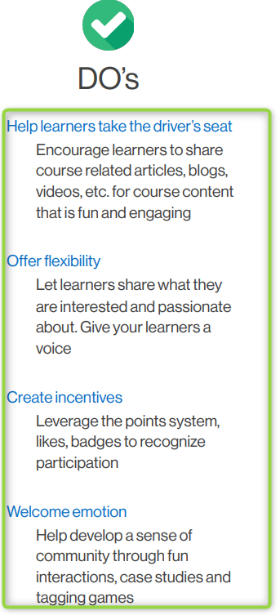

It is also important to set the stage of your classroom. Communicate to your students your classroom expectations. You also want to make sure that you let students get to know you. A key measure of success in your classroom is letting your students realize that you are human, too and have been in their shoes before. Start with some icebreakers and be sure to introduce yourself. Share your past experiences, expertise and a few personal anecdotes.

It is strongly encouraged that as the instructor, you too participate in class. You want to incorporate best practices that will help ensure you and your students are staying engaged and having a positive experience. Let’s take a look at some best practices for instructing the data analytics program:

* Establish your instructor presence early and often. Post announcements, appear on video and participate in discussions. Show students your personality, passion, and expertise.
* Motivate your students by wowing them with your real world experiences. Show students how they will apply what they are learning.
* Break learning into smaller chunks and break out sessions. Get your students in lord with their peers so they can establish a connection early on.
* Describe expectations for online participation, communication, and
* Help students dive right into the content by providing them with:
  + Detailed syllabus and or weekly agenda.
  + Due dates and schedules.
  + Clear challenge, assessment, and workshop directions.
  + Learning Objectives.
* Make sure in class content aligns with course content, objectives, and assessments.
* Provide your students with prompt feedback to help improve their engagement, participation, and communication.

The quality of your interaction between students is a sign of a successful class. Create educational experiences for them that are challenging, enriching, and push their academic abilities. Providing students with opportunities to Incorporating these best practices will help ensure that you and your students stay engaged and have a positive experience.

#### Lesson 2—Lesson Planning

While some instructors use the just wing it approach, the Data Analytics program requires planning and structure, for effective learning. Remember that we need to assume that students are coming into the program with no prior experience of the content. As skilled instructors and professionals, you want to ensure you are ready to go back to the fundamentals and effectively communicate them. We teach students the ability to effectively communicate, so it only makes sense that we prepare to do the same. Now that you have been introduced to program content, resources, best practices, and expectations, let’s introduce you to the final phase in lesson planning.

It is essential for you to prepare lessons, using your given resources beforehand. This will help you implement the most ideal teaching methods. If you plan on attending your classroom sessions without a plan in place, it can be detrimental to you and your students. There is a large emphasis on the importance of lesson planning, because it allows for you to clarify the learning process for each class. It is recommended that you read at least 2 weeks ahead of your students.

You will be provided with the following materials:

* Workshop guided templates for each workshop section containing the following:
  + All modules
  + All lessons
  + All challenge activities
  + All lesson video replays
  + All additional resources
* Instructor Guides (workshop guided template condensed version):
  + Lesson overviews
  + Module learning outcomes
  + Suggested classroom breakdown.

We recognize and appreciate that each instructor will have their own teaching style. It is encouraged that you think outside of the box, get creative, and put your unique spin on your lessons. Below is a list of in-class resources that you can use in the classroom or use to guide you in your planning and development. As a reminder, each module comes with a lesson video replay that summarizes key points of the content. It does not have to end there! If you have something you want to record or share, please do. The goal is to provide you with the materials you need to build your instructor approach and prepare yourself for the classroom experience.

There are different cohorts that will make up this program, part-time and full-time. The content across cohorts will be identical, but the class duration and structure will look different across each. When you are setting the stage and developing your game plan for class, keep in mind that you will need to make use of class time.

* For part-time cohorts, each class will run a total of 180 minutes for each module. A sample instruction schedule based on a part-time cohort can look like this:
  + 60 minutes: welcome and content read
  + 60 minutes: lecture and demo lessons
  + 30 minutes: work on challenges
  + 30 minutes: walk through challenge solutions and wrap up
* For full-time cohorts, each class will run 360 minutes, broken down by morning and afternoon sessions. Each session will run 180 minutes with a break in between. A sample instruction schedule based on a full-time cohort can look like this:
  + Morning session:
    - 60 minutes: welcome and content read
    - 60 minutes: lecture and demo lessons
    - 30 minutes: work on challenges
    - 30 minutes: walk through challenge solutions and wrap up
  + Break – 30 mins
  + Afternoon session:
    - 60 minutes: recap and content read
    - 60 minutes: lecture and demo lessons
    - 30 minutes: work on challenges
    - 30 minutes: walk through challenge solutions and wrap up

The instructor guides serve as baseline direction for the classroom and content areas. As you start to get comfortable, feel free to change things up and move out of that mundane approach.

Here are some completed resources to help you start prepping for your classroom:

* [Instructor Guide Template for Excel](https://docs.google.com/document/d/1dEQi3-IyFM_9tIrv9yD33nVOkYvGbz-D/edit#) - Gives a condensed version of the guided template, for you to focus your instruction and lesson building.
* **Module 1** [Introduction To Data Analytics and Excel Foundations](https://drive.google.com/file/d/1BkntYXOOvWrtLGvwBBL9nZBABmrKQBGH/view?usp=sharing) - Provides you with a deck slide presentation for the first module in Excel.
* **Module 2** [Spreadsheet Formatting and Data Entry](https://drive.google.com/file/d/1L95j4IHYbIrZeEI9AecAyqKcftjiu5gS/view?usp=sharing) - Provides you with a deck slide presentation for the second module in Excel.
* **Module 3** [Basic Formulas and Functions](https://drive.google.com/file/d/1BHbpu6vCGU8nbxvIw6UnXmiITHixSMYs/view?usp=sharing) - Provides you with a deck slide presentation for the third module in Excel.
* **Module 4** [More Complex Functions](https://drive.google.com/file/d/1Ofb5gkAC5nPXAUgTN6uf-wT2pKqioj9N/view?usp=sharing) - Provides you with a deck slide presentation for the fourth module in Excel.

The above templates and deck slides are a guide for you to start building your knowledge and classroom. It is required for you to cover the content in each lesson and prepare students to be successful in the challenge activities. The learning approach and classroom design is yours to create.

Lesson plans are necessary for helping students accomplish their goals within a learning environment on a short-term and long-term basis. Studies show the value of envisioning success in order to attain it.

1. Gain attention:
   1. Obtain your student’s attention so that they will watch and listen while you give lessons.
2. Inform learner of objectives:
   1. Allow your students to organize their ideas and questions for what they are about to see, hear, and/or do. Always check for student understanding and open the room for questions and comments.
3. Stimulate recall of prior knowledge:
   1. Help your students make sense of new information by relating it to something they already know or something they have already experienced. Use this time to recap previous lessons and transition into the current class content.
4. Present new content and examples:
   1. While you have the content to build off of, you also want to give students a variety of methods including lecture, readings, activities, projects, and multimedia to keep them engaged. Lastly, providing additional/outside examples expose students to other situations that they are not aware of. This helps them expand their levels of thinking.
5. Provide guidance:
   1. Advise students of strategies to guide them in learning content and of resources available.
6. Practice:
   1. Allow students to apply their knowledge and skills learned.
7. Provide feedback:
   1. Provide immediate feedback of student performance to assess and facilitate learning.

We know that each class session will be different and can cause last minute adjustments and changes. Here is a suggested format before, during and after your class:

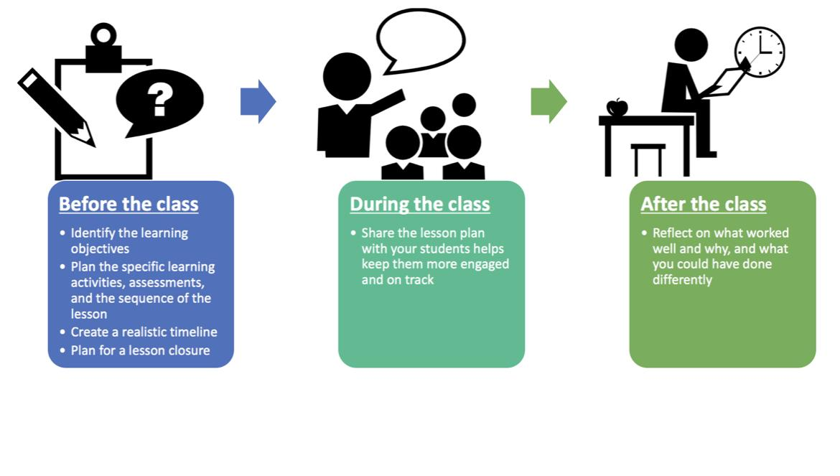

1. Present your lesson plan:
   1. Letting your students know what they will be learning prior to instruction will help keep them more engaged and on track. This is why you are given the module learning outcomes. You can share your lesson plan by communicating a brief agenda on the topics that will be covered.
2. During class:
   1. Providing an organization of class time can help students not only retain what they are learning, but also follow along with your presentation, lecture, and demo lessons. We want them to understand the rationale behind the planned learning activities. Fundamentally, long lectures do not work as well in online teaching, keep that in mind when creating your agenda. Also, practice makes perfect. Be sure to practice your lecture prior to class!
3. After class, reflect:
   1. We know that each class and cohort are going to be different. It is important to take a few minutes after each class to reflect on what worked well and why. Also ask yourself, ‘What could you have done differently?’ Identifying successful and less successful areas of class and activities would make it easier to adjust to the contingencies of the classroom. If you need to, revise your lesson plan.

#### Lesson 3—Grading

##### Challenge Activities:

While working in Canvas, each challenge activity submitted by students at the end of each module will need to be rated on a scale of proficiency. Under the Grades tab in Canvas you will be able to view each challenge submission broken down by module. In order to assign the scale, click on the drop down arrow within the submission box. From there you will want to select the desired rating.

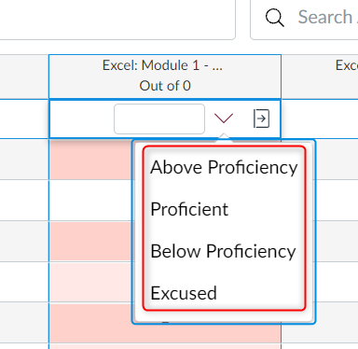

When reviewing student submissions, you will want to make sure that the student has successfully completed all challenge activity tasks. From there, decide the rating for each submission. Below are the rating scale selections:

| Above Proficiency | student is performing above skill level |
| --- | --- |
| Proficient | student is performing at skill level |
| Below Proficiency | student is performing below skill level |
| Excused | student was excused from the submission |

The reason for the rating scale is for instructors and SSMs to visually determine which students are in need of intervention early on the program. This will allow for early student intervention to help students remain successful in the program. If there is a need for intervention, contact your SSM and Director.

##### Assessments:

Students will be required to complete an assessment at the end of each workshop section. The same performance rating scale for the challenge activities will be used. For each assessment refer to the [assessment grading rubric](https://docs.google.com/spreadsheets/d/1NCngVhAesom23OeCm3BIJL-grPzgNa3g/edit?usp=sharing&ouid=114527600735365714926&rtpof=true&sd=true) for how to assess student performance.

Assessments will be available for students at the end of each module for each workshop section. Students will have until the start of the next class to complete and submit their assessment. Assessments are to be completed outside of class!

#### That's a Wrap!

While you will be provided with ample resources, it is encouraged for you to add in professional examples, additional hands-on learning, live demo lessons, and real-world experiences. As the Instructor, you will be responsible for answering student questions. We know that students can challenge us and we will not have the answers to every question that is asked. To make sure that you are able to answer questions and or research the right answer, refer back to all the required and resources that will guide you. Just like we tell our students, do not hesitate to ask questions and reach out for additional help. Good luck and have fun!